Name: ________________________________________________

Step 1: Create a design or shape that you will be able recreate (or at least approximate) with straight lines

Step 2: Plot points on the coordinate plane and draw straight lines between them to recreate your design

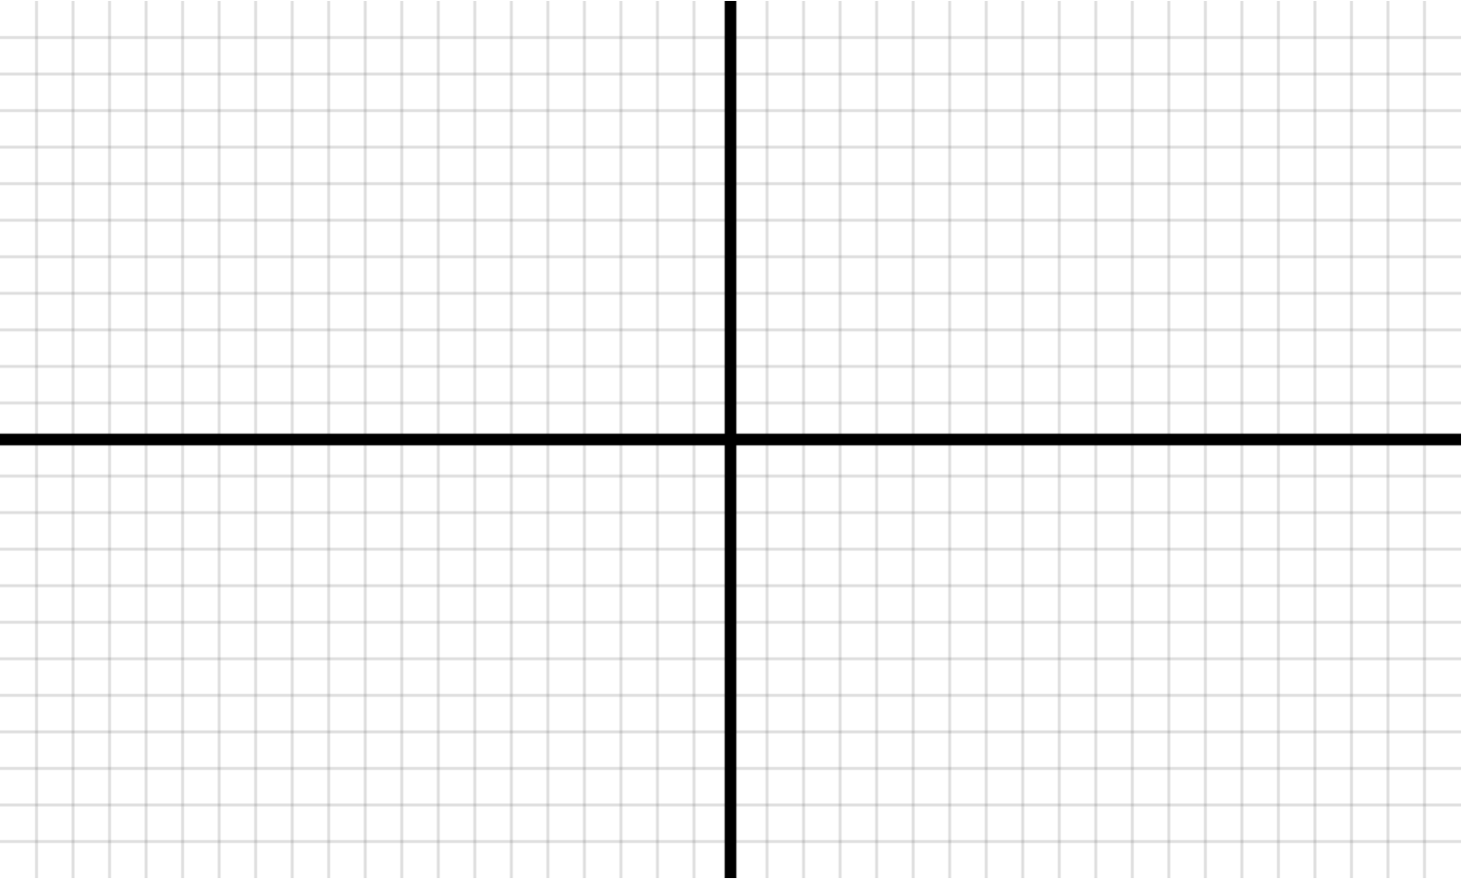

Name: ________________________________________________

Step 3: List the coordinate pairs you used in Step 2 in the order that they are connected. If you want to mirror them across the x-axis or the y-axis, write “Mirror across x-axis” or “Mirror across y-axis” for that step.

1. ________ , ________
2. ________ , ________
3. ________ , ________
4. ________ , ________
5. ________ , ________
6. ________ , ________
7. ________ , ________
8. ________ , ________
9. ________ , ________
10. ________ , ________
11. ________ , ________
12. ________ , ________
13. ________ , ________
14. ________ , ________
15. ________ , ________
16. ________ , ________
17. ________ , ________
18. ________ , ________
19. ________ , ________
20. ________ , ________
21. ________ , ________
22. ________ , ________
23. ________ , ________
24. ________ , ________
25. ________ , ________
26. ________ , ________
27. ________ , ________
28. ________ , ________
29. ________ , ________
30. ________ , ________

Step 4: Pass **only this page** to a partner (**do not show them your design!**) and have them plot and connect the pairs

